**Project Planning Phase**

**Project Planning Template (Product Backlog, Sprint Planning, Stories, Story points)**

|  |  |
| --- | --- |
| Date | 25 June 2025 |
| Team ID | LTVIP2025TMID59290 |
| Project Name | FlightFinder: Navigating Your Air Travel Options |
| Maximum Marks | 5 Marks |

**Product Backlog, Sprint Schedule, and Estimation (4 Marks)**

Use the below template to create product backlog and sprint schedule

| **Sprint** | **Functional Requirement (Epic)** | **User Story Number** | **User Story / Task** | **Story Points** | **Priority** | **Team Members** |
| --- | --- | --- | --- | --- | --- | --- |
| Sprint-1 | Registration | USN-1 | As a user, I can register by entering email, password, and confirming password. | 2 | High | Member A, Member B |
| Sprint-1 | Registration | USN-2 | As a user, I receive a confirmation email after registration. | 1 | High | Member A |
| Sprint-1 | Registration | USN-4 | As a user, I can register through Gmail. | 2 | Medium | Member B |
| Sprint-1 | Login | USN-5 | As a user, I can log into the application via email and password. | 1 | High | Member A |
| Sprint-2 | Registration | USN-3 | As a user, I can register through Facebook. | 2 | Low | Member B |
| Sprint-2 | Flight Search | USN-6 | As a user, I can search flights using source, destination, and date. | 3 | High | Member A, Member B |
| Sprint-3 | Booking | USN-7 | As a user, I can book a flight with passenger details and payment. | 3 | High | Member A, Member B |
| Sprint-3 | Booking History | USN-8 | As a user, I can view my past and upcoming bookings. | 2 | Medium | Member B |
| Sprint-4 | Live Tracking | USN-9 | As a web user, I can track live status of my flights. | 2 | Medium | Member A |
| Sprint-4 | Admin Panel | USN-10 | As an admin, I can add, update, or delete flight records. | 2 | Medium | Member A, Member B |

**Project Tracker, Velocity & Burndown Chart: (4 Marks)**

| **Sprint** | **Total Story Points** | **Duration (Days)** | **Sprint Start Date** | **Sprint End Date (Planned)** | **Story Points Completed** | **Sprint Release Date (Actual)** |
| --- | --- | --- | --- | --- | --- | --- |
| **Sprint-1** | **6** | **6 Days** | **02 June 2025** | **07 June 2025** | **6** | **07 June 2025** |
| **Sprint-2** | **5** | **6 Days** | **09 July 2025** | **14 July 2025** | **5** | **14 July 2025** |
| **Sprint-3** | **5** | **6 Days** | **16 July 2025** | **21 July 2025** | **5** | **21 July 2025** |
| **Sprint-4** | **4** | **6 Days** | **23 July 2025** | **28 July 2025** | **4** | **28 July 2025** |

**Velocity:**

Imagine we have a 10-day sprint duration, and the velocity of the team is 20 (points per sprint). Let’s calculate the team’s average velocity (AV) per iteration unit (story points per day)

**Velocity Calculation**

* **Sprint Duration** = 20 days
* **Velocity** = 10 story points per sprint
* **Average Velocity (AV)** = Velocity ÷ Sprint Duration
* **AV = 10 ÷ 20 = 0.5 story points per day**

🔹 **Team's Average Velocity (AV)** = **0.5 SP/day**

**Burndown Chart:**

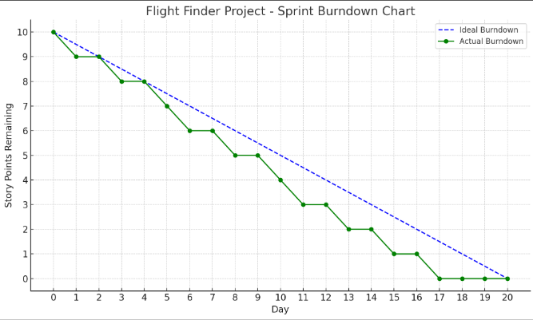

A burn down chart is a graphical representation of work left to do versus time. It is often used in agile[software development](https://www.visual-paradigm.com/scrum/what-is-agile-software-development/) methodologies such as [Scrum](https://www.visual-paradigm.com/scrum/scrum-in-3-minutes/). However, burn down charts can be applied to any project containing measurable progress over time.

[**https://www.visual-paradigm.com/scrum/scrum-burndown-chart/**](https://www.visual-paradigm.com/scrum/scrum-burndown-chart/)

[**https://www.atlassian.com/agile/tutorials/burndown-charts**](https://www.atlassian.com/agile/tutorials/burndown-charts)

**Reference:**

[**https://www.atlassian.com/agile/project-management**](https://www.atlassian.com/agile/project-management)

[**https://www.atlassian.com/agile/tutorials/how-to-do-scrum-with-jira-software**](https://www.atlassian.com/agile/tutorials/how-to-do-scrum-with-jira-software)

[**https://www.atlassian.com/agile/tutorials/epics**](https://www.atlassian.com/agile/tutorials/epics)

[**https://www.atlassian.com/agile/tutorials/sprints**](https://www.atlassian.com/agile/tutorials/sprints)

[**https://www.atlassian.com/agile/project-management/estimation**](https://www.atlassian.com/agile/project-management/estimation)

[**https://www.atlassian.com/agile/tutorials/burndown-charts**](https://www.atlassian.com/agile/tutorials/burndown-charts)